U25AI055
Lab 1
- Write a program for entering array as a row major and print it.
/*
1: Write a program for entering array as a row major and print
it
*/
#include <stdio.h>
int main()
{
int row, col;
printf("Enter number of rows: ");
scanf("%d", &row);
printf("Enter number of columns: ");
scanf("%d", &col);
int arr[row][col];
int i, j;
printf("Enter elements: ");
for (i = 0; i < row; i++)
{
for (j = 0; j < col; j++)
{
scanf("%d", &arr[i][j]);
}
}
printf("Elements are \n");
for (i = 0; i < row; i++)
{
for (j = 0; j < col; j++)
{
printf("%d\t", arr[i][j]);
}
printf("\n");
}
return 0;
}
Output:
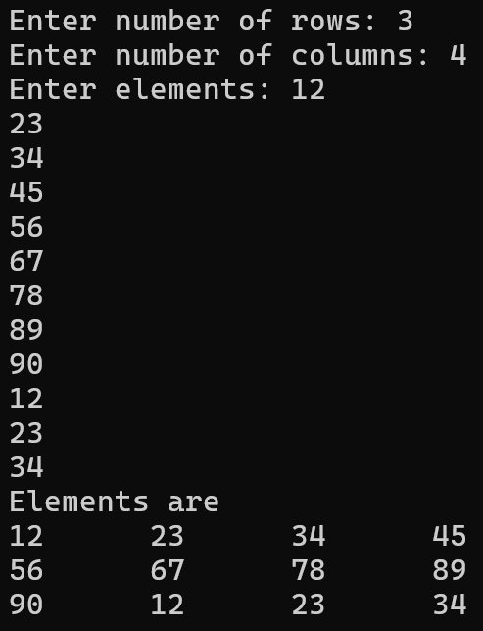
- Write a C program to declare primitive and nonprimitive data types and display the values of variables, their memory addresses, and their sizes for similar and dissimilar data types.
/*
2: Write a C program to declare primitive and nonprimitive
datatypes and display the values of variables, their memory
addresses, and their sizes for similar and dissimilar datatypes
*/
#include <stdio.h>
struct Student
{
int rollNumber;
double percentage;
};
int main()
{
int rollNumber = 12;
char name[] = "Sohan Rane";
float marks[5] = {78.9, 12.3, 23.4, 34.5, 45.6};
double percentage = 67.8;
char grade = 'B';
struct Student student1 = {rollNumber, percentage};
printf("rollNumber value is %d.\nrollNumber size is %d.\nrollNumber address is %u.\n\n", rollNumber, sizeof(rollNumber), &rollNumber);
printf("name value is %s.\nname size is %d.\nname address is %u.\n\n", name, sizeof(name), &rollNumber);
printf("percentage value is %lf.\npercentage size is %d.\npercentage address is %u.\n\n", percentage, sizeof(percentage), &rollNumber);
printf("grade value is %c.\ngrade size is %d.\ngrade address is %u.\n\n", grade, sizeof(grade), &rollNumber);
printf("marks size is %d\n", sizeof(marks));
printf("marks base address is %d\n\n", &marks);
int i;
for (i = 0; i < 5; i++)
{
printf("marks element %d value is %f. marks element %d address is %u.\n", i, marks[i], i, &marks[i]);
}
printf("\nStudent size is %d\n", sizeof(student1));
printf("Student base address is %d\n\n", &student1);
printf("Student rollNumber value is %d.\nStudent rollNumber address is %u.\n\n", student1.rollNumber, &student1.rollNumber);
printf("Student percentage value is %lf.\nStudent percentage address is %u.\n\n", student1.percentage, &student1.percentage);
return 0;
}
Output:
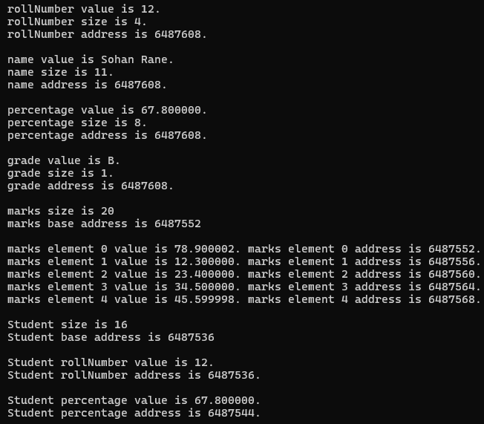
- Given a 3x3 matrix, print the elements and their memory addresses. Demonstrate that in C, the address of A[0][1] follows immediately after A[0][0], proving Row-Major storage. Provide me the solution
/*
3: Given a 3x3 matrix, print the elements and their memory
addresses. Demonstrate that in C, the address of A[0][1]
follows immediately after A[0][0], proving Row-Major storage.
*/
#include <stdio.h>
int main()
{
int matrix[3][3], i, j;
printf("Enter elements: ");
for (i = 0; i < 3; i++)
{
for (j = 0; j < 3; j++)
{
scanf("%d", &matrix[i][j]);
}
}
printf("Elements are \n");
for (i = 0; i < 3; i++)
{
for (j = 0; j < 3; j++)
{
printf("%d\t", matrix[i][j]);
}
printf("\n");
}
printf("Addresses of elements are \n");
for (i = 0; i < 3; i++)
{
for (j = 0; j < 3; j++)
{
printf("%u\t", &matrix[i][j]);
}
printf("\n");
}
return 0;
}
Output:
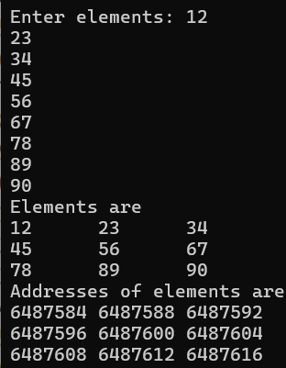
4. Write a program to store N integers in a 1D array. The program should:
5. ​Find the maximum and minimum elements.
6. ​Calculate the average of all elements.
/*
4: Program to store N integers in a 1D array.
5: Find the maximum and minimum elements.
6: Calculate the average of all elements.
*/
#include <stdio.h>
void readArray(int [], int);
void writeArray(int [], int);
int findMaximum(int [], int);
int findMinimum(int [], int);
float calculateAverage(int [], int);
int main()
{
int n;
printf("Enter number of elements: ");
scanf("%d", &n);
int arr[n];
printf("Enter elements: ");
readArray(arr, n);
printf("Elements are ");
writeArray(arr, n);
printf("\nMaximum element is %d\n", findMaximum(arr, n));
printf("Minimum element is %d\n", findMinimum(arr, n));
printf("Average is %f\n", calculateAverage(arr, n));
return 0;
}
void readArray(int arr[], int n)
{
int i;
for (i = 0; i < n; i++)
{
scanf("%d", &arr[i]);
}
}
void writeArray(int arr[], int n)
{
int i;
for (i = 0; i < n; i++)
{
printf("%d\t", arr[i]);
}
}
int findMaximum(int arr[], int n)
{
int i, max = arr[0];
for (i = 0; i < n; i++)
{
if (arr[i] > max)
max = arr[i];
}
return max;
}
int findMinimum(int arr[], int n)
{
int i, min = arr[0];
for (i = 0; i < n; i++)
{
if (arr[i] < min)
min = arr[i];
}
return min;
}
float calculateAverage(int arr[], int n)
{
int i, sum = 0;
for (i = 0; i < n; i++)
{
sum += arr[i];
}
return ((float) sum) / n;
}
Output:
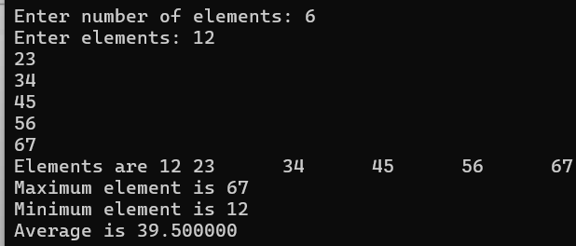
7. ​Perform a Linear Search for a specific key entered by the user.
/*
7: Perform a Linear Search for a specific key entered by the
user.
*/
#include <stdio.h>
void readArray(int [], int);
void writeArray(int [], int);
void searchElement(int [], int, int);
int main()
{
int n, num;
printf("Enter number of elements: ");
scanf("%d", &n);
int arr[n];
printf("Enter elements: ");
readArray(arr, n);
printf("Elements: \n");
writeArray(arr, n);
printf("\nEnter element to search: ");
scanf("%d", &num);
searchElement(arr, n, num);
return 0;
}
void readArray(int arr[], int n)
{
int i;
for (i = 0; i < n; i++)
{
scanf("%d", &arr[i]);
}
}
void writeArray(int arr[], int n)
{
int i;
for (i = 0; i < n; i++)
{
printf("%d\t", arr[i]);
}
}
void searchElement(int arr[], int n, int num)
{
int i, flag = 0, loc;
for (i = 0; i < n && flag == 0; i++)
{
if (arr[i] == num)
{
loc = i;
flag = 1;
}
}
if (flag == 0)
{
printf("Element was not found\n");
}
else
{
printf("Element was found at location %d\n", loc);
}
}
Output:
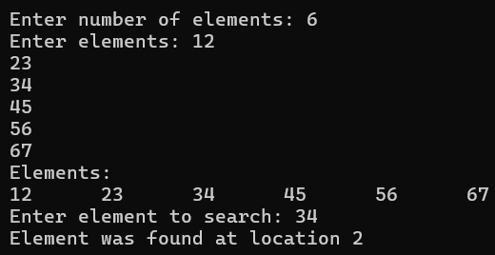
8. Write a C program to calculate the physical memory address of an element A[i][j] using both Row-Major and Column-Major formulas and verify it against the actual address in memory.
/*
8: Write a C program to calculate the physical memory address of
an element A[i][j] using both Row-Major and Column-Major
formulas and verify it against the actual address in memory
*/
#include <stdio.h>
void readArray(int [], int);
void writeArray(int [], int);
int rowMajorOrderFormula(int baseAddress, int row, int col, int i, int j);
int columnMajorOrderFormula(int baseAddress, int row, int col, int m, int n);
int main()
{
int row, col, i, j, m, n;
printf("Enter number of rows: ");
scanf("%d", &row);
printf("Enter number of columns: ");
scanf("%d", &col);
int arr[row][col];
printf("Enter elements: ");
for (i = 0; i < row; i++)
{
for (j = 0; j < col; j++)
{
scanf("%d", &arr[i][j]);
}
}
printf("Elements are \n");
for (i = 0; i < row; i++)
{
for (j = 0; j < col; j++)
{
printf("%d\t", arr[i][j]);
}
printf("\n");
}
printf("\nEnter row number of element: ");
scanf("%d", &m);
printf("Enter column number of element: ");
scanf("%d", &n);
printf("Memory address is %u\n", &arr[m][n]);
printf("Address calculated by row major order formula is %u\n", rowMajorOrderFormula((int)arr, row, col, m, n));
printf("Address calculated by column major order formula is %u\n", columnMajorOrderFormula((int)arr, row, col, m, n));
return 0;
}
void readArray(int arr[], int n)
{
int i;
for (i = 0; i < n; i++)
{
scanf("%d", &arr[i]);
}
}
void writeArray(int arr[], int n)
{
int i;
for (i = 0; i < n; i++)
{
printf("%d\t", arr[i]);
}
}
int rowMajorOrderFormula(int baseAddress, int row, int col, int m, int n)
{
return baseAddress + ((m * col + n) * sizeof(int));
}
int columnMajorOrderFormula(int baseAddress, int row, int col, int m, int n)
{
return baseAddress + ((n * row + m) * sizeof(int));
}
Output:
